ULTRASONIC TESTING REPORT
Company/Client |  | NCOC N. V. |  | Project |  | ESKENE WEST |  | Location |  | Oil Tr-3
Line No/Tag No: |  | A1-200-HA-301B |  | Material |  | Carbon steel |  | Día × Nominal Thickness |  | 2″×5.54mm;  8″×8.18;  12″×9.52;  16″×9.52
Procedure No: |  | QP-11-UTT-Q01 Rev 03  GOST 28702-90 |  | Calibration Block |  | Step wedge |  | Probe  S/N |  | D7908  1214564
 |  |  |  | Calibration block Range |  | 2.50-12.50 mm |  | Angle |  | 0º
Manufacturing Code |  | ASME B31.3 |  | Calibration Temp |  | +3ºC |  | Frequency |  | 7.5 MHz
 |  |  |  | Object Temp |  | +25ºC |  | Size |  | 5.1 mm
Acceptance Standard: |  | Acc. to the client specif. |  | Correction factors |  | n/a |  | Crystal |  | Dual
Surface condition |  | Coated |  | Couplant |  | UT Gel |  | Accuracy |  | ± 0,1 mm
S. No | Equipment/  Material Name |  | Manufacturer |  | Serial No |  | Calibration certificate No |  | Calibration Expiry date
 | 45MG |  | OLYMPUS |  | 181113402 |  | BK-01-0673 |  | 20-03-2020
 | Step wedge calibration block |  | NDE-TECH |  | 0272119 |  | - |  | -
Job description:

- UT spot check performed on pipeline:
A1-2003-RO-005-16″-A11-HC (A1-200-HA-301B); KE01-A1-200-PZ-P-DI-2084-002
A1-2003-RO-007-20″-A11-HC; KE01-A1-200-PZ-P-DI-2086-001
- Inspection performed on West, East, South, North, Top, Bottom, Intrados and Extrados from external.
- Echo to echo UT technique was use.
Notes:
N/A – not applicable.

Inspection drawing
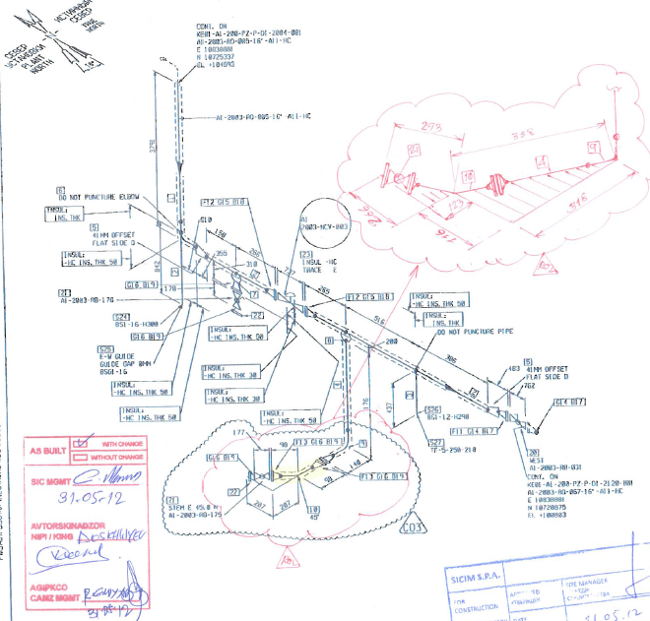
CML-08
CML-13
CML-12
CML-11
KE01-A1-200-PZ-P-DI-2084-002
TEE-01
1
2
1
2

Results
S/NO | Line No | Item description | Spot check  Location | DIA(Ø), inch | Nominal thickness, mm | East  mm | West  mm | South  mm | North  mm | Top  mm | Bottom  mm | Extrados  mm
1 | KE01-A1-200-PZ-P-DI-2084-002  TEE-01  PIPE-02  1  2  1  2 | CML-08  (Reducer) | 1 | 16 | 9.52 | 10.46 | 8.69 | - | - | 9.87 | 10.19 | -
1 | KE01-A1-200-PZ-P-DI-2084-002  TEE-01  PIPE-02  1  2  1  2 | CML-08  (Reducer) | 2 | 16 | 9.52 | 11.38 | 10.40 | - | - | 11.87 | 10.61 | -
1 | KE01-A1-200-PZ-P-DI-2084-002  TEE-01  PIPE-02  1  2  1  2 | CML-08  (Reducer) | 3 | 16 | 9.52 | 12.12 | 10.91 | - | - | 12.91 | 10.87 | -
2 | KE01-A1-200-PZ-P-DI-2084-002  TEE-01  PIPE-02  1  2  1  2 | CML-11  (Elbow) | 1 | 2 | 5.54 | - | - | 6.17 | 5.84 | - | - | 5.75
3 | KE01-A1-200-PZ-P-DI-2084-002  TEE-01  PIPE-02  1  2  1  2 | CML-12  (Elbow) | 1 | 2 | 5.54 | - | - | - | - | 5.76 | 6.10 | 5.56
4 | KE01-A1-200-PZ-P-DI-2084-002  TEE-01  PIPE-02  1  2  1  2 | CML-13  (Reducer) | 1 | 16 | 9.52 | 10.10 | 10.54 | - | - | 10.26 | 10.07 | -
4 | KE01-A1-200-PZ-P-DI-2084-002  TEE-01  PIPE-02  1  2  1  2 | CML-13  (Reducer) | 2 | 16 | 9.52 | 11.08 | 11.35 | - | - | 11.99 | 10.29 | -
4 | KE01-A1-200-PZ-P-DI-2084-002  TEE-01  PIPE-02  1  2  1  2 | CML-13  (Reducer) | 3 | 16 | 9.52 | 11.47 | 11.89 | - | - | 12.60 | 10.75 | -

Inspection drawing
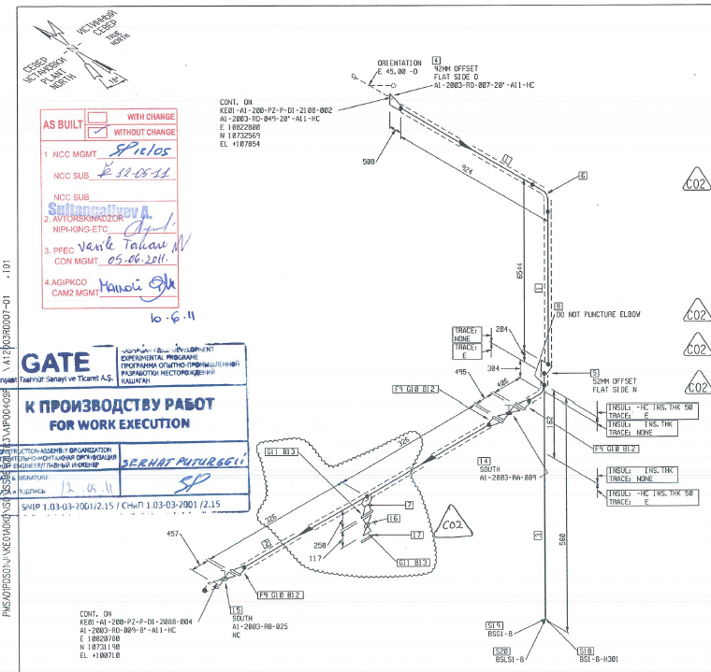
CML-03
CML-04
KE01-A1-200-PZ-P-DI-2086-001

Results
S/NO | Line No | Item description | Spot check  Location | DIA(Ø), inch | Nominal thickness, mm | East  mm | West  mm | South  mm | North  mm | Top  mm | Bottom  mm | Extrados  mm | Intrados  mm
1 | KE01-A1-200-PZ-P-DI-2086-001  TEE-01  PIPE-02  1  2  1  2 | CML-03  (Reducer) | 1 | 12 | 9.52 | 9.52 | 9.62 | 9.47 | 9.83 | - | - | - | -
1 | KE01-A1-200-PZ-P-DI-2086-001  TEE-01  PIPE-02  1  2  1  2 | CML-03  (Reducer) | 2 | 12 | 9.52 | - | - | - | 9.94 | - | - | - | -
1 | KE01-A1-200-PZ-P-DI-2086-001  TEE-01  PIPE-02  1  2  1  2 | CML-03  (Reducer) | 3 | 12 | 9.52 | 12.28 | 13.59 | 14.63 | 10.22 | - | - | - | -
2 | KE01-A1-200-PZ-P-DI-2086-001  TEE-01  PIPE-02  1  2  1  2 | CML-04  (Elbow) | 1 | 8 | 8.18 | - | - | 8.70 | 8.77 | - | - | 8.91 | 8.48
2 | KE01-A1-200-PZ-P-DI-2086-001  TEE-01  PIPE-02  1  2  1  2 | CML-04  (Elbow) | 2 | 8 | 8.18 | - | - | 8.59 | 8.81 | - | - | 8.29 | 9.40
2 | KE01-A1-200-PZ-P-DI-2086-001  TEE-01  PIPE-02  1  2  1  2 | CML-04  (Elbow) | 3 | 8 | 8.18 | - | - | - | 9.22 | 8.62 | - | 8.53 | 9.14

Examined by  UT L II cert. No 263  exp. date: 08.01.2021 | Name: Zakharov Vadim | Signature: ............................ | Date: 22 December 2019
Approved by  UT Level II cer. No 1A 253/15  exp date: 31.05.2020 | Name: Shakunou Andrei | Signature: ............................ | Date: 22 December 2019
Client Representative: | Name: …………………………… | Signature: ............................. | Date: ………………………

